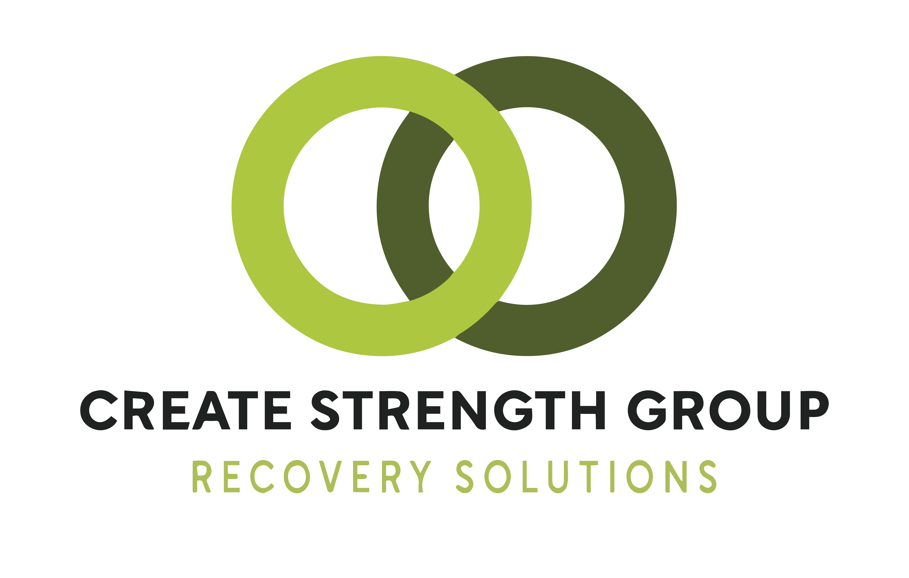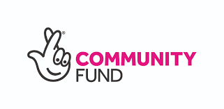
Create Strength Group, 35 Salem Street. Bradford BD1 4QH - Registered Charity No: 1193551 - www.cslhg.org
Job Description Ref: NLRC-FJR01-2022-PAD

Create Strength Group (CSG): Founded in March 2015, Create Strength Group’s heritage lies in providing support to long-term chronic users of cannabis, spice and legal highs, Create Strength Group has evolved beyond this core focus to now provide essential information, advice, assistance, and support to anyone whose life is being affected by their own, or someone else’s, addictive behaviour.
We host dynamic mutual aid support groups in local venues and online where experience and advice are shared in a safe non-judgmental abstinence-based user led environment. We use, web, social media, and emerging technologies to promote our proven delivery model. We believe all drug users have the ability to turn their lives around and make positive, sustainable changes to their personal circumstances and the communities they live in.

The serious issues we address include anxiety and depression, sleep and insomnia, unemployment, homelessness and poverty, offending, and child custody issues. Our target members might be living isolated, anxious, and unfit for work or social activity.

We have consistently achieved transformative improvements in our hard to reach and seldom heard diverse cohort, supporting members with serious lifelong addictions, and have helped them grow and develop into volunteering, employment and general health and wellbeing.

The group's services include-mutual aid, training, and research.

Title of post: PROJECT ADMINISTRATOR

Responsible to: PROJECT LEAD

Hours: 40 HOURS p.w –Full-time

Salary: £20,400 pro rata - with 2% rise after 12 months
Location: Central Bradford/Online
Progression: 6-Month Probation (NJC-Scale AA-4.9by July 2023)
Annual Leave: The post holder is entitled to 26 days paid holidays per year (pro rata)

Role Purpose: To support the project lead in the planning & delivery of the organisation’s services by providing administration and support skills as needed.
The Project Administrator is a pivotal role within the charity, supporting the Project Lead in providing effective administrative support.
Main responsibilities
1. Proactive role in supporting the Project Lead
- Act as a central point of contact, providing professional and proactive support and ensuring confidentiality and discretion where required.
- Ensure the Project Lead is effectively briefed and prepared for meetings and activities, taking a proactive approach to seeking updated information where appropriate.
- Provision of proactive day-to-day business support for the Project Lead.
- Act under agreed levels of delegation from the Project Lead to transact matters on their behalf.

2. Project Support
- Take responsibility for the project governance process flow and administration and provide secretariat support for meetings, training sessions and other activities.
- Work closely with the Project Lead to support the production, co-ordination, maintenance and evaluation of project plans, and ensure milestones are met.
- Support the Project Lead to develop and implement fundraising/ marketing strategies
- Build and maintain close rapport with the CSG Team, Board of Trustees and all internal and external stakeholders, acting as an ambassador for the Project Lead.
3. Continuous Improvement
- Drive quality and efficiency improvement in the operation of the Project through process improvements, use of technology and automation, including how information is shared, presented, managed, documented and prioritised.
4. Team Member
- Role models CSG values and behaviours
- Work and behaves in accordance with all CSG policies and procedures.
- Upholds the fundamental principles of the charity and acts with integrity.
- Undertakes any other relevant duties as may be required by the Project Lead.

5. Supporting Service Users
- Manage correspondence and enquiries via email, phone web and social media
- Triage associate support needs and signposting to appropriate services.
- Manage referrals liaising with statutory services.
- Update databases, registers and knowledge systems.

Person Specification

Essential | Desirable
Skills, knowledge and Experience
MS Office skills particularly Word/PP/Excel | An understanding/Lived experience of addiction & recovery
Positive outlook and team player | Experience of supporting management or project teams
 | Experience of peer support networks
 | Proficient use of Google Calendar, Google Drive
 | Facebook and Twitter group, page and account management

Pre engagement Checks: The successful candidate will undergo an enhanced DBS check and will be asked to provide a professional and personal reference.
Closing date for applications: 23:59 on 01/06/2022 with interviews w/c 13/06/2022
Send applications to: jobs@createstrengthgroup.org

Further Information: If you require further information about the role or wish to have an informal conversation regarding any aspect of the application process, please contact Dave Memery on 07563 184362 dave.memery@cslhg.org
Web: https://cslhg.org https://createstrengthgroup.org
Twitter: https://twitter.com/cslhginfo
Facebook: https://www.facebook.com/cslhg

